

|  |  |  |  |  |  |  |  |  |
| --- | --- | --- | --- | --- | --- | --- | --- | --- |
|  | | | | | | | | |
|  | | Success in the NHL | | | | |  | |
|  |  | | | | | | |  |
|  | | | |  |  | | | |
|  | | | | Andrew Kehl |  | | | |
|  | | | | 23 May 2021  —  Data Visualization  —  Andrew Bond |  | | | |
|  | | |  | | |  | | |

Table of Contents

Success in the NHL 1

Abstract 3

Overview 4

Tools 5

6

Data and Model 6

Time 6

Geo-Location 10

Findings 14

References 14



## Abstract

The goal of this project is to determine some of the not-so-obvious factors which can contribute to a hockey player’s success. For our purposes we are going to define success as playing at least one game in the National Hockey League. Specifically, the factors we are going to look at are the what part of the year the player is born and where in the world they are born. For the most part, we are trying to answer this question through visualizations rather than calculations and this report will reflect that. What we found is that being born in colder climates with larger populations plays a major role in whether somebody will make the NHL. We also, more interestingly, found that being born early in the year plays a major role in whether somebody will be successful in hockey due to the relative age effect.

## Overview

In the book *Outliers,* author, Malcom Gladwell talks a bit about the effect birth month can play in the role of a hockey player’s success. While Gladwell does a brilliant job of this, the book itself is about the factors of success, not specifically of hockey players. The point of this paper is to expand on Gladwell’s findings specifically looking at hockey players and to explain some of these findings through visualizations where Gladwell tried to explain through words. Beyond that, Outliers was first published in 2008, with time some of these things can change so we will be looking at newer data.

There are two distinct areas we will be looking at, the time of year a player was born, and the location in which they were born.

## Tools

#### Introduction

The goal of this section is to introduce and explain the tools used in this project for purposes of clarity and replication.

#### Python

Python is used to simply parse the data together. One of the models required data directly from the NHL unfortunately, the NHL has a front-end stats downloader which will only output a maximum of 100 rows at a time and we needed much more data than that, so the data had to be downloaded in 100 row chunks and Python 3.9 and the Pandas and CSV libraries were used to concatenate that data into a single CSV. For those uncomfortable with Python, this could have been done in Microsoft Excel or Google Sheets without much issue.

#### Excel

Excel was used for basic data exploration and very mild cleaning. Working with such a relatively small amount of data, no program is quicker for a simple data exploration.

#### Tableau

Given that one of the goals of this project is to answer questions using mostly visualizations, a visualization platform is necessary. For our purposes Tableau was the right choice but there are dozens of other platforms that could be used for most of these visualizations without issue.



#### Photoshop

All platforms have pros and cons and while Tableau makes most visualizations very easy, it is limited in some ways. One of those limitations is the inability to have three axis geographical visualizations and it just so happens one of the visualizations we needed was just that. Instead we separated the geographical visualization into two different images and layered them in Photoshop. This was likely unnecessary as the maps could have been displayed next to each other while only losing some understandability.

## 

## Data and Model

### Time

#### Introduction

As stated earlier, the goal here is to determine factors of a hockey player’s success, for this section we will explore this through the time of year a player is born.

#### Dataset Introduction

The most important dataset used here was biographical data of all NHL players from the 2011-2021 seasons. Players needed to have played at least one game in that time to be included. While there was a whole lot of extra data included. Really, the only data we were interested in was birth place, birth date and the player’s name as a unique identifier. This data is available through the NHL REF1 but can only be retrieved in 100 rows at a time. The data was combined into a csv. There are 2333 players included in the dataset.

The only other data that was used for this section was provided by the Canadian government. REF2 It is simply the date of every birth in Canada for the period of 1991-2001.

#### 

#### Vis1

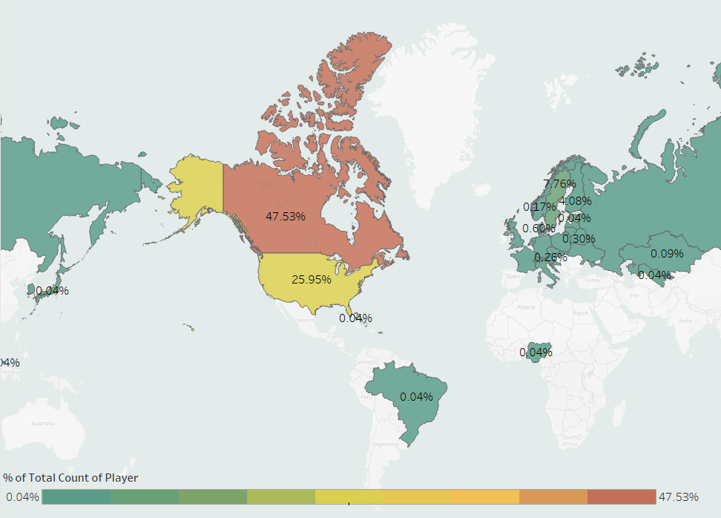

This first visualization shows us the breakdown of the birth countries of NHL players from 2011-2021. This is important because we are only going to look at North American players and this shows us that nearly 75% of NHL players from that time period were born in North America. This visualization is to demonstrate that the data is not being cherry-picked, we have a highly relevant dataset.

Both Canada and the United States have a January 1st age cutoff for youth hockey programs. Every age group has a different team, players born in 1993 are on this team and players born in 1994 are on that team. The thing is if you are born on January 1st you will almost assuredly be the oldest player on your team while if you are born on December 31st you will almost assuredly be the youngest player on the team. Most people gloss over that, because on the surface it shouldn’t really matter if a player is on this team or that team.

But what if it does? Gladwell purports that it could matter because of opportunity. The oldest player on a team will more often stand out from the crowd. In your mid-twenties a year doesn’t make a major difference in cognitive or physical abilities but at 7 or 10 years old, a year is a major difference

Further, youth players that stand out will have their parents told they are gifted and may put them into special programs. Scouts will see that player and recruit them for competition teams, getting them more ice time and better players to play against. The point is that players who stand out on a team may be given greater opportunities and a player may stand out not because they are gifted but instead because they are older than their peers. This is a known phenomenon called the Relative Age effect

At this point we have gone over why age could matter, but now its time to actually explore the data and see if it actually does matter.

#### Vis2

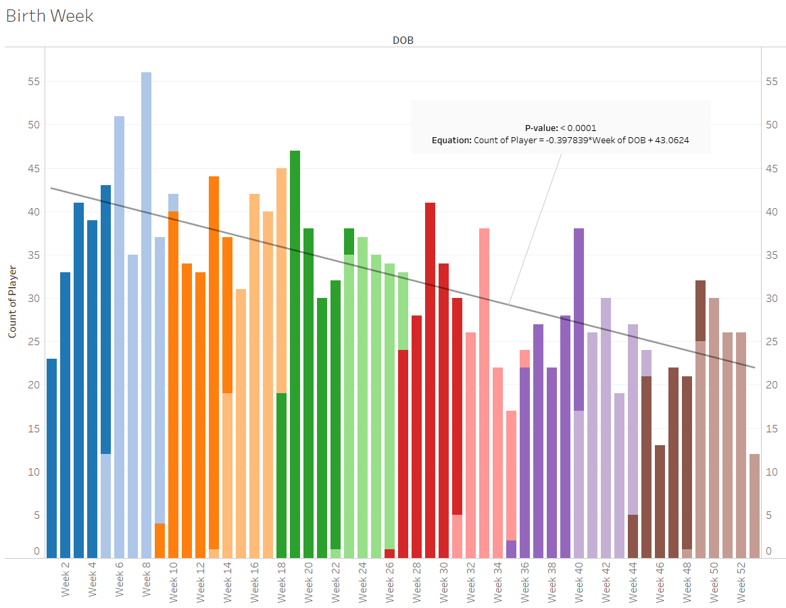



The above chart plots the quantity of NHL players born in each week. These are only NHL players born in the US or Canada and have played at least one game in the NHL from 2011-2021. Months are broken down by color. A least squares linear regression line was fitted to the model showing a very obviously negative slope.

Let’s take another look at the same data.

#### Vis3

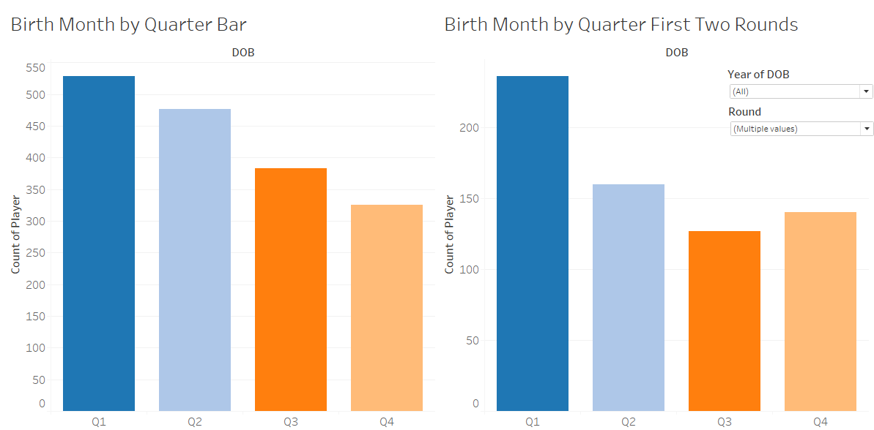

Above, on the left, the data is identical to the previous chart but instead of breaking it down by week, it is broken down by birth quarter. The trend here is still obvious. On the right we can see similar data but instead of looking at the entire NHL we are only looking at players that were drafted in the first two rounds. Players drafted in the first two rounds are the players that have been scouted as the best candidates for the NHL, the players that stand out on their teams, the players who have been given opportunity. Does that sentence sound familiar? As the chart shows, the disparity in when a player is born is even greater in the first two rounds than the rest of the NHL.

At this point we have gone over why being born early in the year might matter, and we have shown that there are consistent and significant trend of more players being born early rather than later in the year, but there is an obvious question that also needs to be answered; what other factors could contribute to the birth rate discrepancy. This is a subject that could be studied extensively itself but the least we could do is take down the most obvious alternative possible solution. We know there are more players born early in the year, but is that simply following the population?

#### Vis4

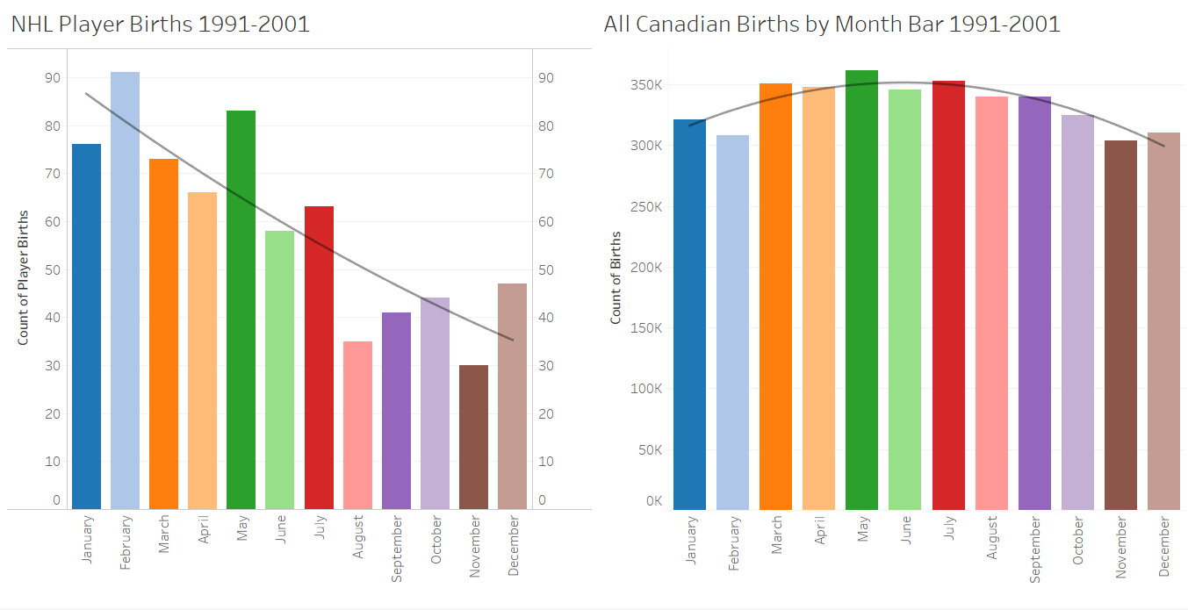

The above shows NHL births of Canadian players on the left and all births in Canada on the right. On these two, the trendlines are two-degree polynomial least-squares regression lines. Canadian births seem to peak mid-year while NHL births peak early in the year. These bar charts do not match, births by time of year of Canadian players do not match all Canadian births in the same time period. This does not explain the disparity of NHL players being born early in the year.

While total births do not explain this phenomenon, there are of course other possibilities, maybe total Canadian births by month don’t match but what if total hockey player births do match? There are a hundred questions one could ask just like that but the most reasonable answer is that in North America being born early in the year will make someone more likely to make the NHL.

We have one personally uncontrollable factor that contributes to making the NHL but this begs the question; what other factors could contribute?

### Geo-Location

#### Introduction

Location obviously plays a huge factor in opportunity. For the most part a person born in the right zip-code or in the right country will have much better opportunities than others. Usually this is due to money. For future NHL players could it be more than just money?

#### Dataset Introduction

For this section we will continue to use the same NHL biographical data we have already been working with. We also will be using two different sources of weather data.

#### Vis1

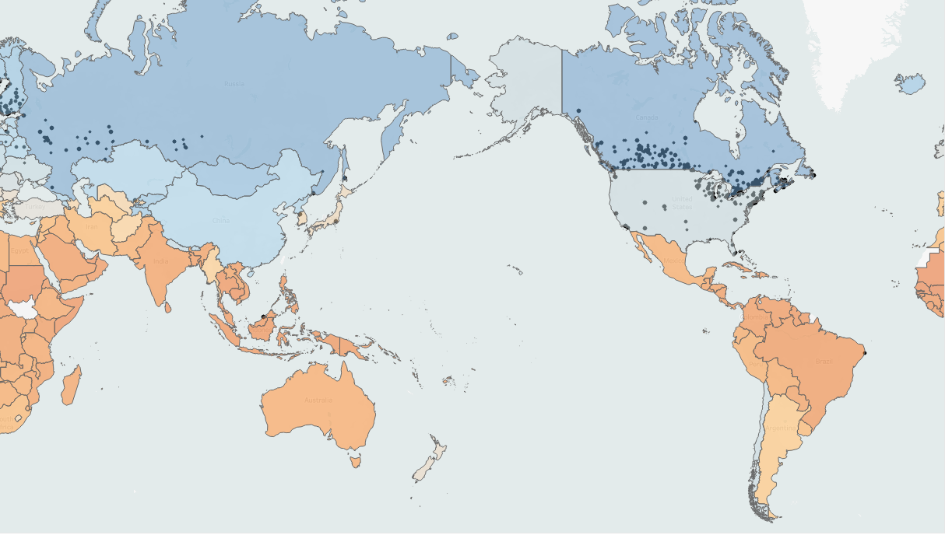

This map shows the birthplace of every player in the NHL along with the average temperature of each country. There is a very clear trend here. Areas that are colder with any sort of population worldwide have players who make the NHL. The NHL is the premier hockey league of the world, there are other pro leagues but the best players usually join the NHL because of the higher wages and the prestige of the league. It makes sense that for the most part only people from colder climates end up playing professional *ice* hockey. Hockey simply requires ice to play and the more ice around, the more people will be playing. This is true on a macro scale, country wide, but is it true on a smaller scale?



#### Vis2

As the map above shows, most of the American NHL players do in fact come out of places in the US that have colder temperatures. There are some very obvious places on this map where that isn’t true, there are a few major metro areas that seems to be hotspots for player births but don’t have colder temperatures. Some of the NHL fans reading this might notice a consistency here in the areas that are warm but have players being born there.

#### Vis3



The majority of our not so cold player hotspots can be explained away by NHL teams being located there. NHL teams are for the most part located in major metro areas and only major metro areas of places where it gets cold have ice. Cold locations get pond hockey in winter at the very least, and warm locations require indoor rinks and only major metro areas have the population to support these indoor rinks. Beyond that when an NHL team sprouts up in an area then more people become hockey fans and put their children into youth hockey, some of which eventually turning into NHL players. Further, NHL teams often build excess indoor rinks for their community to support practices and such, places where youth players can get their start

## 

## Findings

We haven’t proved anything here; this was merely an exploration of data through visualizations and given possible explanations for phenomenon. With that being said, there is a lot of credence here to the relative age effect on whether or not a player makes the NHL. We know there is more to making the NHL than innate talent and we have the relative age effect and birth location as possible explanations for some amount of success here.

There are many more factors that can explain someone’s success in hockey beyond talent, location and relative age, just like there are many explanations for success in just about any field in the world. We can leave with two questions; do we call Wayne Gretzky ‘The Great One’ if he were born in Brazil; If you want your kid to make the NHL are you going to aim for a January or December birthdate?

## References

All data sources, visualizations and codebase can be found at my GitHub link.

<https://github.com/AndrewKehl/Vis_NHL>

*Outliers* by Malcom Gladwell

<http://www.nhl.com/stats/>

<https://open.canada.ca/data/en/dataset/d412e6d0-879d-4632-baed-9b8cb25a94b7>

<https://web.archive.org/web/20150905135247/http://lebanese-economy-forum.com/wdi-gdf-advanced-data-display/show/EN-CLC-AVRT-C/>

<https://www.currentresults.com/Weather/US/average-state-temperatures-in-winter.php>